FORT KING
PRESBYTERIAN CHURCH
LINK LITE
September 2020

PASTORAL PONDERINGS

Native American Spirituality has fascinated me for a long time. Their practice of good ecology long before it became a pressing necessity; honoring of the wisdom of elders and listening to the stories of ancestors; their appreciation for silence and spending time observing nature are all things I feel are close to the values I want to include in my spiritual life. One thing many Native nations practice is paying attention to the animal world. There is a belief that when a particular animal appears in your path, be it while awake or while asleep, they are messengers from the Great Spirit meant to nudge you to pay attention to particular aspect in your life. For example, the bear in most Native stories represents courage, commitment to protect your family (especially your kids) and strength. If a bear appears while hiking or in a dream, you are being encouraged to exercise the virtues of strength, courage and protection of the young in your life. A friend of mine who is Christian and Native said that animals are the Native American equivalent of angels. They are guardian and guides in Native spiritual life.

Recently, a rabbit began hanging out at my house. Rabbits are not common where I live. In Colorado, the coyotes kept rabbit populations down, so it had been years since I had seen one in the wild. When this one began hanging outside my yard, I wondered what message a rabbit might represent. I was raised on Peter Rabbit stories. I don’t presently have a garden that would make me a Farmer McGregor or concerned for loss of crops. I checked my books on Native American stories and discovered the rabbit represented playful spirit, something in this Covid restricted time was missing in my life. Seeing the rabbit made me realize it had been awhile since I had played a game, gone on a day trip, danced, or listened to music from my CD. That rabbit pushed me to find ways to be more playful and not just responsible and careful.

The church book club recently discussed the book How to Be a Good Creature. It was the story of a naturalist who focused on 13 different animals that had come into her life that had impacted her. There were dogs of course, but also a pig, emus, an octopus and even a tarantula! Each helped her face a special challenge or make a needed change in her life. So… here’s to paying attention to the creatures that cross your path this year. They may be a messenger from God for you.

SEPTEMBER SCRIPTURES FOR SERMONIZING

September 6: James 3:1-12 What’s Burning COMMUNION SUNDAY
September 13: James 3:13-4:10 Let There be Peace on Earth
September 20: James 4:13-5:12 Who Knows What Tomorrow will Bring?
September 27: Marianne Nielsen brings us the sermon
October 4: James 5: 13-20 The Power of Prayer WORLD COMMUNION AND PEACE MAKING OFFERING

Crossroads II Class
Program for Fall, 2020
Read: Genesis 1:1-31 see also Psalm 104
We are all part of God’s intricate and amazing creation. We did not bring ourselves into being, rather we receive our existence as a gift from God. Our lives are interwoven with all of creation, including the stars, planets, oceans, animals, trees, and plants around us. We are all part of creation that God has made and declared good.
God created all the cosmos in an intricate interwoven system of life. When humanity elevates one group over another, or falsely declares particular groups less good than others, we usurp God’s place as creator of all that is. We deny our interrelation and proclaim our judgment more powerful than God’s.

Matthew 25 Initiative:
Dismantling Structural Racism

The Adult Discipleship Ministry invites you and all of your friends to join the Crossroads II class each Sunday morning at 9:15 via Zoom. Our focus this Fall will be one of the three parts of the Matthew 25 initiative: Dismantling Structural Racism. We suggest that you purchase or borrow (several in Church library) the book How to Be an Antiracist by Ibram X. Kendi. That will be our focus.
This is the schedule for September:

September 6 – Introduction to the Matthew 25 Initiative – Dismantling Structural Racism

Leaders: Daniel Banks, Judith Bullen and Mary Beth Neely

September 13 – Video on Structural Racism by Phil Vischer – with discussion

Leader: Mary Beth Neely

September 20 – Discuss the book How to Be an Antiracist by Ibram X Kendi.

Leader: Julee McCammon

September 27 – Discuss the book How to Be an Antiracist by Ibram X. Kendi

Leader: Barbara Fitos

October 4 – Discuss the book How to Be an Antiracist by Ibram X. Kendi

Leader: Susan Peters
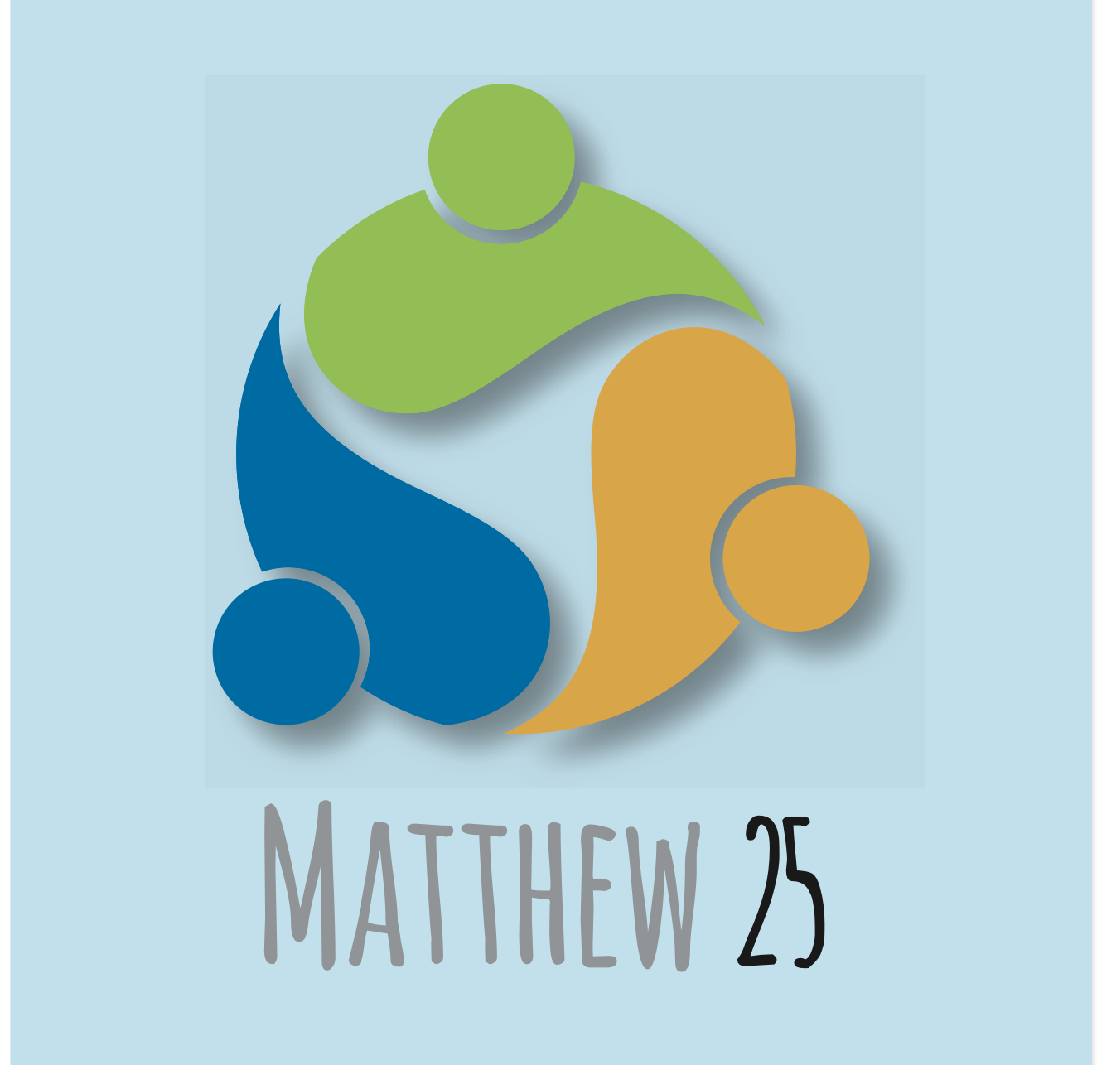

LIBRARY NEWS

LIBRARY NEWS
The church library now has 2 hardback copies of How to Be an Antiracist and expects to receive a LARGE PRINT softback copy when it is released in mid-September. If you want to check out one of these copies, please call the church office to find out if one is available and tell Sheri when you would like to pick it up.
Louise Olivarez, FKPC Librarian

CONGREGATIONAL CARE

Wonderful members of our church continue to touch base with congregants to check up on them and see how they are doing. However, please remember that you can reach out to them as well. We want to know if there is a need. We also are happy to share the gift of fellowship. Reach out anytime. Not sure who to call or what the number is? Give Gina Camilleri a call at 352-622-8867 and she will make sure you connect with your congregational care contact.
Have you updated your Emergency Contact Form yet? Hurricane season is here so it is important that
we have up to date contact info for ALL our church family. If you need forms, please contact Sheri at the church
office.
Congregational Care is meeting via Zoom. Our next meeting is Tuesday, September 8th at 2:00. If you
would like to “attend” the meeting, please contact Gina Camilleri and she can send you a “Zoom” invitation.

MISSION:

MISSION CURRENT EVENTS and OPPORTUNITIES
- July 26th: Blood bus on campus. At least six donors.
- July 28th: Law Enforcement First Responders at seven locations received snacks from FKPC, delivered by Mission members. Many smiles and thank yous.
- Estella Byrd Whitman Clinic: monthly donations for the rest of 2020 and all of 2021 to help with salaries.
- August 3rd: Drive-By Supplies/Food Collection for Domestic Violence and Interfaith. Extremely successful. Both entities were very excited for the donations.
- August 21st: Muffins and fresh fruit were taken to the faculty and staff of Wyomina Elementary School. This school does not have an active PTO, so they were very appreciative. Look forward to other ways that we can help this school.
- August 26: Worship Ministry covered the Interfaith meal for this month.
FUTURE OPPORTUNITIES
We will work toward having a drive to help our current FKPC teachers (L. Fuller, C. Martin, M. Martin, and
E. Merriam).
**FAIR TRADE ITEMS will be for sale on Monday, September 14th since the Office is closed on September 7th (Labor Day). These goods will be displayed in the hallway beyond the Office from 9:00-noon.
THANK YOU to each group, Ministry, family and individual who has participated this month with the Mission of FKPC. Help us to keep it going!!
MISSION (CONTINUED)
Help Our Teachers
This year as school is starting, the Mission Ministry would like all of us to remember our teachers in your prayers and if you are able, to help them in their classrooms by donating a gift card or items for them to use with their students. We have four teachers who have just started meeting with their students, here is a short list of the ways you can be helpful to them.
1. Lorraine Fuller - she teaches pre-school handicapped children at Wyomina Park Elementary. Lorraine has young students and she buys and keeps on hand for them snacks that she uses throughout the entire school year. She does not want them to be sugary snacks, so she has requested individual sized Goldfish crackers, animal crackers or vanilla wafers. She would be grateful for any snacks that we can add to her classroom supplies. If you buy something for Lorraine, please drop it by the office and she will come by to pick it up.
2. Kate Martin - she teaches dance, as an elective, to high school students at Belleview High School. The only thing that Kate says she needs this year is help in buying the music that she uses in class. She would appreciate any Amazon gift cards that would allow her to order music for her students. Please drop the gift cards off in the church office.
3. Michael Martin - he teaches band, as an elective, at Lake Weir Middle School. As a middle school band teacher, Michael has various needs. He buys sheet music for his students and also must buy reeds and even sometimes parts for their instruments. He would appreciate Visa gift cards that would allow him to either order online or to go to Parramore Music here in town to purchase some of his needs.
4. Emily Merriam - she teaches TV Production, as an elective, to high school students at Vanguard High School. Emily has specific needs for her classroom, she needs SD memory cards for students to use to create their presentations. She also needs flash drives (16 gigabytes) for them to save their work on. She needs odd batteries, like a watch battery, to power her microphones, and cleaning supplies for her cameras and computers. All of these items could be donated or you could just give her an Amazon gift card and she would order them. She also uses hard candies as an incentive when her students can answer questions correctly, so you could buy some candy and drop it off in the church office.

Please keep these teachers and their students in your prayers and if you are able to help with their needs, drop your items off in the church office. Thank-you,
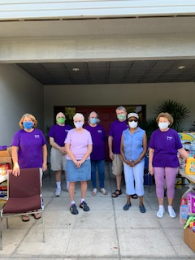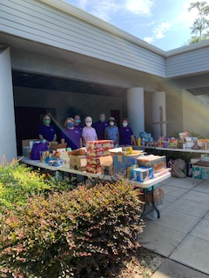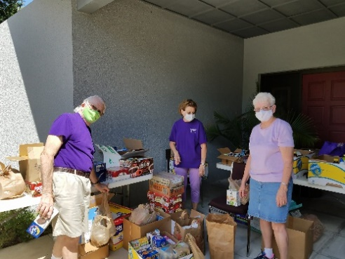
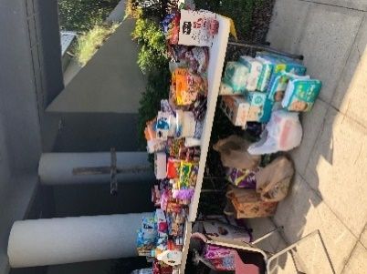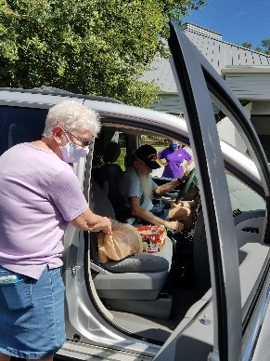

The Drive-up Food Drive for Interfaith and Domestic Violence was a big success. Thank you FKPC!
HAPPY BIRTHDAY
September Birthdays

9/5 - Larry Bush 9/14 - Danielle Stracuzzi
9/7 - Midge Barrett 9/19 - Debbie Bush
9/7 - Allen Hall 9/20 - Jo Anne Dyson
9/7 - Lily Rasco 9/24 - Ray Ruark
9/8 - Ed Camilleri 9/25 - Donna Johnson
9/8 - Judy Harriss 9/26 - Gene Moore
9/9 - Nilsa McNeil 9/27 - Joan Woods
9/11- Ann Dyson 9/28 - Jane Garrett
9/30 - Kathy Bohner

BOOK
CLUB
Book Club resumes via ZOOM at 3:00 PM.
Sept 22: The Book of Longings by Sue Monk Kidd. Leader: Barbara Fitos. Zoom Host: Mary Beth N.
September: https://us02web.zoom.us/j/83624454926 Meeting ID: 836 2445 4926

The Link will be sent to all who were at the meeting or request it. It will also be sent to the church office.

ZOOM OPPORTUNITIES:
We can’t meet together in a building, but we are meeting in many places via Zoom, an app that you download
and then use to connect for Worship, Session, Tai Chi. Some committees are meeting via Zoom.
Please check with your chair for those links. Here are the times and links or contacts for our programs.

Worship: Sundays at 10:30 AM - Contact Sheri, she will send the worship links every Friday.
Youth: Contact Cadance for day and link.
Tai Chi: Thursdays at 3:00 PM Contact Mary Beth Neely
Session: Third Wednesdays at 4:30 PM, September 16th. Contact Mary Beth Neeley or Church Office
Mission Ministry: September 1st at 4:30 PM. Contact is Sue Thomas
PW Counsel meeting September 2nd at 2:30 PM Zoom Team 4. Contact is Heidi Lawson
Adult Discipleship Ministry Meeting: 1st Thursday, September 3, 2020 at 1:00 PM, Contact Mary Beth Neely
Congregational Care: Second Tuesday at 2:00 PM. Contact Gina Camilleri.
Choir September 17, and 24 (Zoom) at 4:00 PM.
Worship Ministry: next meeting is October 4, 2020 at 1:00 PM, Contact Joan Woods/Judith Bullen
Finance Ministry, September 10th at 1:00 PM. Contact is Steve Layendecker

YAK MINISTRY TEAM MEETING

The Yak Ministry Team will meet Monday, September 21st at 6:30 P.M. in front of the church. We will be outside socially distancing and wearing masks because of our COVID-19 guidelines.

ART-4-ALL

Curbside Art-4-All is the 3rd Sunday of the month. Next pickup date will be September 20th (3-5pm)
weather permitting
We have some very enthusiastic participants! Stop by and get in touch with your artistic side.
DONATIONS

Thank you Phyllis Altonn and Joe Tyler for the donations of a walker, rollator and additional wheelchair.
We are still in need of crutches and a shower chair for our medical closet. I check these items out at the church. If you have any of these items and are not using them, please donate today. Thank you. Sheri

PEACE AND GLOBAL WITNESS SPECIAL OFFERING – PEACEMAKING AND RECONCILIATION
SUNDAY, OCTOBER 4, 2020

On World Communion Sunday, October 4, we celebrate:
- that Christ’s peace extends throughout all creation
- that we are all together at the table in God’s house
- that we are offered what we need to continue the work of building the household of God with active peacemakers here at home and around the world.
Christ invites us all – despite our differences, experiences, and pasts – to come to the table as one body and to make peace through reconciliation and advocating for God’s justice. We celebrate the truth found in 2nd Thessalonians, “May the God of peace give you peace at all times in all ways.”
Through the Peace and Global Witness Offering, we offer healing, peace, and reconciliation. In joining the Offering, we serve God’s people in Cameroon, where violence and conflict threaten, in the USA with ministries of reconciliation inside prison walls, and in Malawi, where peacemakers seek to eradicate diseases like HIV-AIDS and their impacts on the most vulnerable.
Thank you for your participation in the Peace & Global Witness Offering.
- 25% of this offering stays with our congregation to support peacemaking and reconciliation in our own community.
- 25% will go to our mid council, joining with other congregations in our area to support peacemaking work in our region.
- And 50% of this Offering supports the work for peace and reconciliation being done by Presbyterians across the globe.
May the God of Peace inspire us to be peacemakers in every word and deed as we celebrate World Communion Sunday on October 4 and give generously to the Peace & Global Witness Offering.
PEACE IS ACTIVE, NOT PASSIVE, PEACE IS DOING, NOT WAITING

RECYCLING

When you see these labels on boxes or bags of food, etc., Do NOT cut them out because they are NOT the
actual box tops that you send into the school. If you have a smartphone or a tablet, all you need to do now is
download the Free Box Tops for Education app and then in that app you press scan and it will search your
grocery store receipt, to see if there's any products that are worth money for Ward Highlands School. In the
app, you just type in the name of the school that you're saving for. It's easy as you don't have to clip and store
and bring them into church. When you use the app and scan your receipt, the money immediately goes to the
school of your choice.
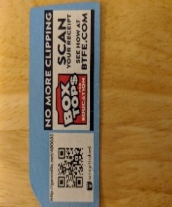
PRAYERS FOR THE PEOPLE

We are happy to pray for anyone who is in need. Concerns will stay on this list for a month
unless we hear otherwise. Please keep us updated.

IN CARE CENTERS:
Margy and Dick Marshall: Brookdale at Pinecastle, Margy is at home with Dick. She is on Hospice at home.
Aileen Zimmerman: Harbor House, Dunnellon
Bob Rile: The Bridge
Caroline Sperring: Timber Ridge Nursing and Rehab
Fred Stewart: Oakhurst

FOR THOSE WITH HEALTH CONCERNS:
Those battling cancer: Lyle Hamilton, David McChesney, Bob Lamont, Diane (Georgia Butler’s Daughter)
will have surgery on 8/25/20, Dick Marshall had infusion this week, John Wolf started second round of
chemo, prayers for good appetite and tolerance of food, Bobbie Ward, and David Lee, Pastor of Highlands
Presbyterian of Jacksonville.

FOR THOSE AT HOME WITH HEALTH ISSUES: Jane Garrett, Mary Jo Bernier, Judy Simonin, Maria Madigan,
Nell Blumel, Melvin Winkler, Judy O’Hern is at home, Nilsa McNeil, Janet Mitchell, Jeannie Tyler,
Bobbie Burns, Midge Barrett, Bob Henry, Shirley Orme, Ginny Spring’s grandson, Derek has medical issues,
Nancy Copeland’s sister, Kay has COPD and is home in CA with Physical Therapy/Occupational Therapy and
Afriyie Dankyi’s, 3 year-old grandson has a broken arm.

FOR THOSE SERVING IN AT RISK JOBS: (Please inform of others. We know we are missing some)
Military: Jessica F Raker, Dick and Nancy Haydon’s granddaughter serving in Air Force in Anchorage,
Alaska. In hospitals or Health Care Centers: Afriyie Dankyi, Georgia Butler’s son, Ray and Moseley’s
daughter, Marla, is a psychologist in a hospital out west that has COVID cases, Shelly Dyson (Jo Anne’s
sister in law), Allison and Greyson Thomas, Steve and Sally Layendecker’s daughter, Janine Layendecker.
Sally’s niece, Andrea Day had COVID, and she is better and back to work. Jenny McChesney, ER Nurse at
ORMC (Susan Jensen’s daughter-in-law), Jenny’s parents in Miami now have COVID and Kathleen
Polston’s sister, ICU nurse, Anne Wheat.

IN THE HOSPITAL:
Charlanne Brown’s mother, Delores Sedlack, is in the hospital NY, she fell and broke her hip.
Bob Henry will have surgery on 9/4/2020, Please keep Bob and Bernice in your prayers.
Bill Lowe (Marcia Border’s Father in Law)
Kent (Friend of Donna Lavery with pneumonia)

OTHER:
Dick and Nancy Haydon’s Aunt, Flo Pinkston, broke her ankle and has other medical issues. Please keep Flo and family in your prayers.
Families in relational stress
A family member in jail
Folks looking for work.
Savannah, 14-year-old with severe brain injury in Colorado, she is home and will have one year of therapy.
Melanie Baum’s church was vandalized. Appears to be due to racism.
Joyce Ellen Horne started a new job at Department of Health this week.
Charles and Mary Ellen’s Vowinkel’s friend, Leo Smith needs prayers, he has Covid 19

Annette George, Missionary from Thailand had a fire at her home in Thailand. Due to COVID, she is not allowed to return this year.

All people in Care Centers are restricted from visitors at this time. Why not send a card to them?

WORSHIP MINISTRY:

Judith Bullen has words of wisdom to share this month:
“Since we worship apart, may we double-down in prayer for peace and healing!”

As worship continues by way of Zoom, the Worship Ministry is planning ahead for this special 2020 Advent.
We encourage you to share creative worship ideas leading up to and including Christmas. We are grateful for
your helpful ideas.
God bless you all,
Joan Woods & Judith Bullen
Co-Chairmen of Worship

September  2020  Sunday | Monday | Tuesday | Wednesday | Thursday | Friday | Saturday
 |  | 1  10:00am Bible Study  (Zoom)  4:30pm Mission (SR)  (Zoom) | 2  2:30pm PW  Council (Zoom)  1:30 & 4:30  Live Streaming Consult | 3  1:30 Adult  Discipleship (Zoom)  3:00pm Tai Chi  (Zoom) | 4 | 5
6  9:00am Drive in  Worship  (communion)  10:30am Worship  (Zoom)(Communion) | 7  HOLIDAY  OFFICE CLOSED  LABOR DAY | 8  10:00am Bible Study  (Zoom)  2:00pm Congregational  Care (Zoom) | 9  1:30 & 4:30  Live Streaming Consult | 10  1:00pm Finance  (Zoom)  3:00pm Tai Chi  (Zoom) | 11 | 12
13  9:00am Drive in  Worship  10:30am Worship  (Zoom) | 14  9-12 Selling Equal  Exchange Products | 15  10:00am Bible Study  (Zoom)  2:00 Congregational  Care (Zoom) | 16  4:30 Session (SR)  (Zoom) | 17  Sheri - off  3:00pm Tai Chi (Zoom)  4:00 Choir Practice  (Zoom) | 18  Sheri - off | 19
20  9:00am Drive in  Worship  10:30am Worship  (Zoom)  Art-4-All, 3-5pm  Curbside | 21  Pastor Jo Anne –  Off Sept 21 - 27  6:30 pm YAK Ministry  Meet outside church | 22  3:00pm Book Club  (Zoom) | 23  Interfaith Meal at  5:00pm Hosted by  PW Council | 24  3:00pm Tai Chi  (Zoom)  4:00 Choir Practice  (Zoom) | 25 | 26
27  No Drive in Worship  10:30am Worship  (Zoom) Rev.  Marianne Niesen | 28 | 29  10:00am Bible Study  (Zoom) | 30

